**Image Log and Questions for the Game**

**Description:** This document serves as the image log for our game project. It includes descriptions, locations, questions, and answers for each image taken across different campus locations. The purpose is to provide a reference for integrating these images into the game, making them interactive elements that players can engage with. Development team members can use this log to understand the context of each visual asset and its corresponding gameplay question, ensuring consistency and clarity in the game development process.

**Image 1: Brinkley Center Tunnel**

* **Image Description:** The tunnel leading to the Brinkley Center
* **Location:** The walkway connecting to Brinkley Center on ETSU campus.
* **Question:** Which building does this tunnel path connect to?
* **Answer:** Brinkley Center

**Image 2: Burgin E. Dossett Hall**

* **Image Description:** The front view of Burgin E. Dossett Hall, with the globe sculpture in the foreground.
* **Location:** Front entrance of Burgin E. Dossett Hall.
* **Question:** Which building is this sculpture located by?
* **Answer:** Burgin E. Dossett Hall

**Image 3: The D. P. Culp Student Center Cave Exhibit**

* **Image Description:** Indoor cave exhibit, showcasing the geological features and rock formations.
* **Location:** Inside the D. P. Culp Student Center, near the cave exhibit area.
* **Question:** Where is the cave with these rocks located at?
* **Answer:** D. P. Culp Student Center

**Image 4: Lucille Clement Hall**

* **Image Description:** Front view of Lucille Clement Hall with its main entrance and classical columns.
* **Location:** Main entrance to Lucille Clement Hall.
* **Question:** What building does this entrance lead to?
* **Answer:** Lucille Clement Hall

**Image 5: ETSU/Ballad Health Athletic Center**

* **Image Description:** View of the ETSU “Mini Dome” with the prominent 'E' logo visible.
* **Location:** Exterior of the ETSU/Ballad Health Athletic Center
* **Question:** What is the name of this building?
* **Answer:** ETSU/Ballad Health Athletic Center (Mini Dome)

**Image 6: Parking Services Building**

* **Image Description:** The ETSU Parking Services building with cars and surrounding trees.
* **Location:** Parking Services Office, ETSU campus.
* **Question:** What is the name of this building with the drive through?
* **Answer:** Parking Services Building

**Image 7: Reece Museum**

* **Image Description:** Interior of the Reece Museum featuring 'The Fletcher Exhibit'.
* **Location:** Inside Reece Museum, showcasing the exhibit area.
* **Question:** Which building is showcasing these historical & contemporary exhibits?
* **Answer:** Reece Museum

**Image 8: The Carillon Tower**

* **Image Description:** An upward shot of the Carillon tower with the wreath hanging above.
* **Location:** Underneath the “Bell Tower” on the ETSU campus.
* **Question:** What is the official name of this tower?
* **Answer:** The Carillon Tower

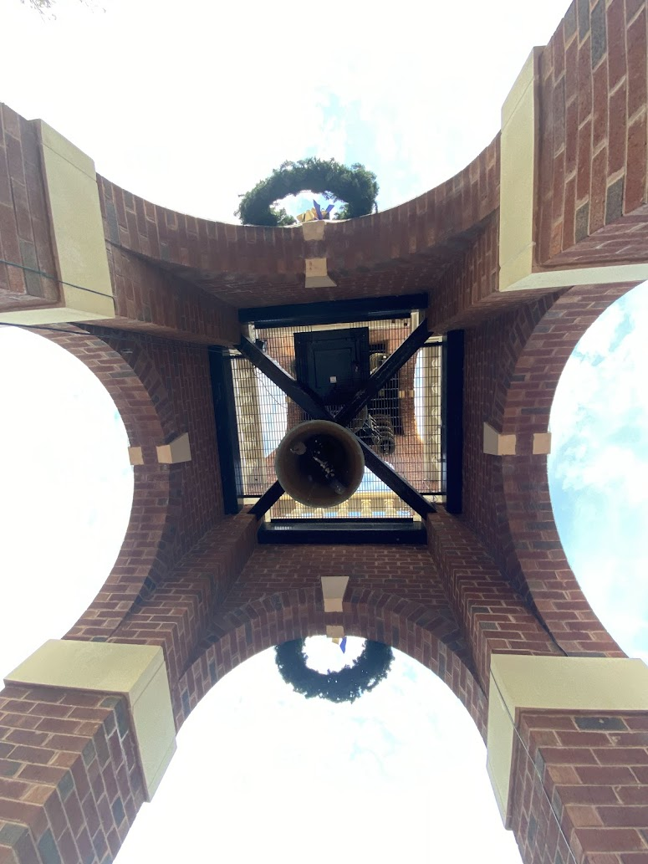

**Image 9: Tri-Hall Field Gazebo**

* **Image Description:** The gazebo located at Tri-Hall Field, surrounded by trees.
* **Location:** Tri-Hall Field area, near the gazebo.
* **Question:** Whereby on campus is this gazebo located at?
* **Answer:** Tri-Hall Field

**Image 10: William B. Greene Jr. Stadium**

* **Image Description:** Entrance to William B. Greene Jr. Stadium, with the sun setting through the gate.
* **Location:** East entrance to the William B. Greene Jr. Stadium.
* **Question:** Where does this entrance lead to?
* **Answer:** William B. Greene Jr. Stadium

